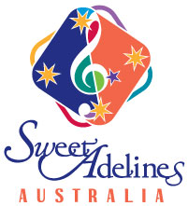
YOUTH DEVELOPMENT BHA/SAA

YOUTH FUNDING REQUEST FORM

GENERAL INFORMATION

Proposed Location:
Proposed Date/Time:
Style of event: | - Secondary School Workshop  - 18-26 Workshop Event  - Youth Festival @ Regional Contest  - Other:
Primary Contact:
Proposed Faculty:
Description:

Please include a brief proposed schedule and intended outcome - youth exposure, membership growth etc.

PROJECTED BUDGET
Funding requested:
Please include as required, or note if donated:
- Music requirements
- Venue costs
- Promotional Materials
- Faculty fees
- Travel / Accommodation expenses
- Any other outlays

Item | Cost estimate
Total Budget: | $
Other sources of funding:
- Local grants: $
- Club/Chorus support: $
- Other/Donations: $

